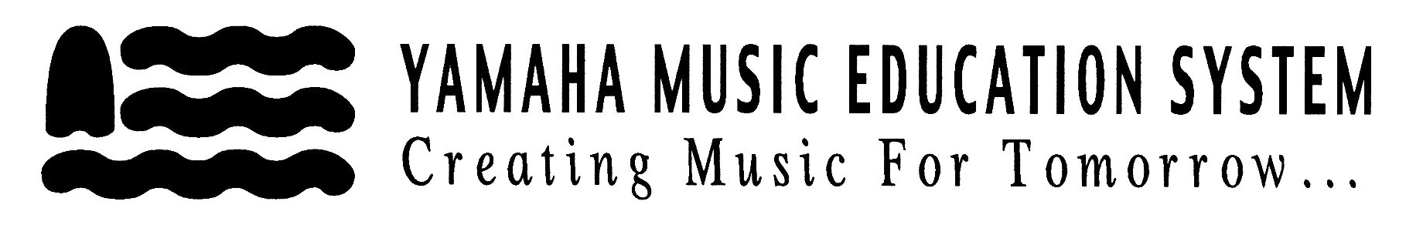

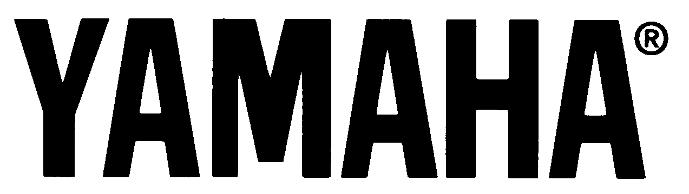
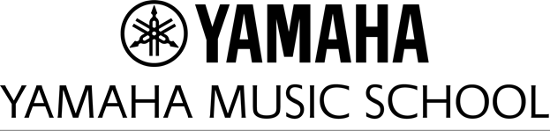
169 Enterprise Blvd, 3rd Floor, Markham, ON L6G 0A2
Tel: (416) 224-5590, Fax: (416) 224-0290
school@yamaha.ca www.yamahamusicschool.ca
YAMAHA MUSIC SCHOOL

Seniors

Teens &
Adults

11

10

9

8

7

6

5

4

3

2

AGE:

YOUNG
MUSICIANS
COURSE

PIANO
CLUB
VIOLIN COURSE

KEYBOARD
CLUB
SENIORS
KEYBOARD
CLUB
MUSIC WONDERLAND
Apple
JMC1
JMC2
JMC3
JMC4
J

S

A

C
JUNIOR MUSIC
COURSE (JMC)
S
A
C
JUNIOR ADVANCED COURSE 2
JUNIOR ADVANCED COURSE 1
GUITAR COURSE
SAXOPHONE COURSE
FLUTE COURSE
ELECTRIC GUITAR / ELECTRIC BASS COURSE
DRUM COURSE



We ARE music!

Enrollment Calendar
2018- 2019

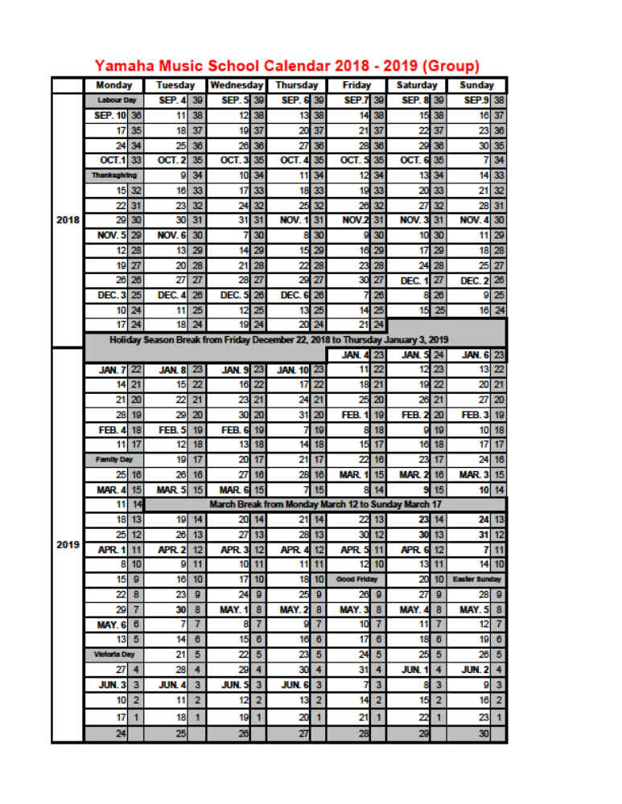
44

Please note: Yamaha Music School may change the dates for the March Break depending on the dates the school boards set.

If a make-up lesson cannot be scheduled at a mutually convenient time, a credit is issued if a completed Credit Request Form is signed by the instructor and submitted to the front desk. Please note that a maximum of 2 lesson cancellations with 24 hours’ notice, including make-ups, are accepted for credit per student per school year. Multiple cancelling/re-scheduling of the same lesson counts as multiple cancellations.

TERMINATION: Written notice for 4 consecutive lessons is required to withdraw from lessons. Written notice may be given on the Yamaha Music School Withdrawal Form, by email to school@yamaha.ca, or by letter submitted to the front desk at least 24 hours before your next lesson. The 3-lesson period commences upon receipt of the Withdrawal Form. Tuition is payable for the duration of the 3-lesson period whether lessons are attended or not. Tuition refunds will not be granted for withdrawal notices received after Monday, April 1^{st,} 2019 (no refundable lessons for May 2019 or June 2019). It takes approximately 60-90 days for refunds to be processed. Informing an instructor of intent to withdraw, or not attending classes, does not constitute withdrawal from lessons. There are no refunds/credits for SKC except due to illness (a physician’s letter must be provided).

SUSPENSION OF STUDENTS: Yamaha Music School reserves the right to suspend students for non-payment of tuition or inappropriate conduct.

CANCELLATION OF INSTRUCTION: Yamaha Music School reserves the right to withdraw any course or level of instruction, or to change an instructor of any lesson, or to close any Music Centre location at any time without notice or liability other than to refund tuition fees received for lessons cancelled due to such withdrawal or closing.

TRANSFER FEE: A $20.00 transfer fee is charged to students transferring to a new lesson/day/time/instructor after September 30th.

LESSON START DATE: Yamaha Music School reserves the right to determine the start date for all lessons. Start dates may be postponed if enrollment is not sufficient to form a group.

RESULTS OF MUSIC EXAMINATIONS, ASSESSMENTS AND/OR COMPETITIONS: There are no refunds or credits for fees paid for music examinations, assessments and/or competitions, or for tuition paid for lessons that may include preparation for music examinations, assessments and/or competitions where any party deems the results of said music examinations, assessments and/or competitions unsatisfactory. Yamaha Music School accepts no responsibility for results students achieve on music examinations, assessments and/or competitions. Students and/or parents are encouraged to fully discuss the requirements and expectations of music examinations, assessments and/or competitions with their instructor in advance of submitting an application.

UNATTENDED MINORS: Yamaha Music School does not assume any responsibility for the well-being and safety of minors who are left unattended on school premises, in common areas and the underground parking areas at 169 Enterprise Blvd.
43

Table of Contents
page | 1 | Manager’s Message
 | 2 | The Yamaha Method
 | 5 | Music Courses By Beginner’s Age
 | 6 | Registration Process: As Easy as 1, 2, 3
 | 7 | Apple Course
 | 8 | Music Wonderland
 | 8 | Music Makes You Smarter!
 | 9 | Junior Music Course
 | 10 | Why Group Lessons?
 | 11 | Junior Advanced Course
 | 12 | Junior Special Advanced Course
 | 13 | Creating Creative Thinkers
 | 14 | Young Musicians Course
 | 16 | Piano Club
 | 17 | Keyboard Club
 | 18 | Seniors’ Keyboard Club
 | 20 | Class Expectations and Behavior
 | 21 | Popular Music Courses
 | 22 | Guitar Course
 | 23 | Refer a Friend + Testimonials
 | 24 | Violin Course
 | 25 | Flute Course
 | 26 | Saxophone Course
 | 27 | Drum Course
 | 28 | Music Theory
 | 29 | Performer’s Club
 | 30 | Yamaha Orchestra
 | 31 | Private Lessons
 | 33 | Studio Rental
 | 34 | Why Use Keyboard Instruments?
 | 35 | Practice Coach Program
 | 36 | Practice Tips
 | 37 | Parking
 | 38 | Determining the Most Suitable Home Keyboard
 | 39 | Yamaha Dealers – Greater Toronto Area
 | 40 | Why Buy Our Instruments?
 | 41 | Non-Tuition Fees
 | 42 | Yamaha Music School Policies
 | 44 | School Calendar & holiday schedule

Spring 2018

At Yamaha Music School, we know that in today's world, we need to deliver excellence in order to be successful. This is especially true when it comes to teaching music in a creative and unique way. Our instructors and staff believe that the Yamaha philosophy of music education is one of the reasons that differentiate us from the rest and make the YMS the premier music school in the Greater Toronto Area.

Here are a few examples of why we are unique in comparison with other music schools:

-Teachers -- Our instructors have a genuine commitment to teaching music. This is reflected by their education and experience when they join the school. Yet that is not enough: we are the teacher-training and R&D centre for Yamaha courses across Canada, ensuring continuous professional development.

-Curriculum – Yamaha Music Foundation creates and designs its curriculum and materials including textbooks, CD's, DVD's, and other materials that combine musicians’, educators’ and child psychologists’ decades of experience in music education.

-International History – Yamaha Music School in Toronto is the only school that is owned and operated directly by Yamaha Canada Music. It is part of a vibrant international network of Yamaha schools in over 45 countries. More than seven million graduates in the past 60 years have learned music through the Yamaha method, so Yamaha qualifications are recognized internationally.

-Fun and Rewarding – Our students discover that they can have fun and achieve a high level of music proficiency.

-Performances -- Performance opportunities are available in a wide variety of settings, from monthly in-school recitals to community festivals and competitions.

We believe that Yamaha music education courses are second to none!
Thank you for joining us at Yamaha and believing in the power of music!

Stephen Couldridge
Manager, Yamaha Music School
National Manager, Music Education Dept.
Yamaha Canada Music Ltd

1

YAMAHA MUSIC SCHOOL POLICIES
REGISTRATION AND PAYMENTS: The terms covered by the registration agreement will be considered in effect upon Yamaha receiving payment or payment information for the holding of a class placement. Informing an instructor or the office of intent to register without complete registration and payment will not hold a student's placement. Full payment must be received at the time of registration. Full payment includes annual registration fee, tuition fees, concert and finance fees (if applicable) and any outstanding payments from the previous school year. Lessons cannot start until registration is complete.

NSF OR DECLINED PAYMENTS: A $20.00 NSF fee is applied to a student account for each NSF cheque. Lessons can stop upon our notification of a NSF cheque or declined payment, and will resume once account is brought up to date. Three consecutive NSF cheques or declined payments will suspend the payers account and shall only be reactivated upon payment in full.

PROOF OF REGISTRATION: Students must bring proof of registration – a copy of the registration form issued by the school office – to the first lesson to be admitted and receive any applicable materials.

REGISTRATION FEES: A registration fee is payable once per academic year per course. The academic year is from September 1 to August 31. Registration fees for additional courses are waived providing they are of equal or less value than the first fee. If the added registration fee is higher than the first, the difference is payable. Registration fees are nonrefundable once the student has begun lessons. $50.00 Cancellation Fee is retained for students who register but do not begin lessons. $20.00 Cancellation Fee is withheld for students who do not begin SKC. The registration fee is refunded if Yamaha Music School cancels the group.

TUITION FEES FOR SMALL GROUPS: Yamaha Music School reserves the right to adjust the length of lesson time at any point in the year should the size of the group class decrease as follows:
Size of Group Tuition Fee Length of Lesson
3 students group rate 45 min lesson
2 students group rate 30 min lesson

ANNUAL CONCERT FEES: A concert fee is part of the annual tuition fees for group course students, except students in Apple, MW, JSAC/SAC, SKC, Orchestra and Theory. There is no tuition credit or refund of the concert fee if the student does not attend the concert or terminates (drops out of) lessons.

MISSED GROUP LESSONS: Homework assignments are made available to parents and students for missed group lessons.
Extra help sessions may be scheduled at the instructor’s discretion. Missed group lessons are not refunded unless the school or the instructor cancelled the class.
MISSED PRIVATE LESSONS: Private lessons (and make-up lessons) cancelled by the student can be made up provided that a minimum of 24 hours’ notice is received by the instructor and the cancellation is due to good cause (illness).

42

NON-TUITION FEES
Registration Fee | ● refundable, minus cancellation fee, if written withdrawal notice is received by the administrative staff before the date of the first lesson.  ● non-refundable after student begins lessons.
Cancellation Fee | ● $20.00 for SKC and Orchestra students whose written withdrawal notice is received by the front desk staff before the date of the first lesson.  ● $50.00 for all other students whose written withdrawal notice is received by the front desk staff before the date of the first lesson.  ● Cancellation Fee may be waived due to illness if a physician’s letter is provided.
NSF Fee or Declined Payments | ● $20.00 for each NSF cheque.
Transfer Fee | ● Waived if written transfer request is received by the front desk staff on or before Sept. 30th for any current registration.  ● $20.00 if written transfer request is received by the front desk staff after Sept. 30th, of the academic year for any current registration.
Concert Fee | ● Equivalent to 1 lesson tuition fee.  ● Payable by all group lesson students except students in Apple, MW, JSAC/SAC, SKC, Theory and Orchestra.  ● Non-refundable after registration, regardless of concert attendance.
Monthly Finance Fee | ● $3.00 per month per student is included in the Monthly Finance Plan total.

41

The Yamaha method

Yamaha Music School at 169 Enterprise blvd: Yamaha Music Education programs began in Canada in 1966. The National Education Department for Yamaha music education in Canada is located at 135 Milner Avenue in Toronto, Ontario. All national Yamaha programs are developed in conjunction with the Yamaha Music Foundation in Japan. The Yamaha Music School at 169 Enterprise Blvd, Markham, Ontario is owned and operated by Yamaha Canada. For more than 25 years, this flagship school has been the national research and development centre and teacher training facility for Yamaha Canada.

Music Education Philosophy
The Yamaha philosophy for music education is based on the belief that everyone has the potential to develop musical ability. Yamaha believes that everyone has the capacity to create, perform and enjoy one's own music, and that through this joy of music one can enjoy a richer life.

In the early 1950's, a research team of excellent teachers, physicians, psychologists and musicians were brought together to develop a new and effective way of teaching music. Through much discussion, research and experimentation, a unique and remarkable educational system, now known as the Yamaha Music Education System, evolved. The four main characteristics of the Yamaha Education System are:

1. Timely instruction
2. Comprehensive musical training
3. Group lessons
4. Systematic education program

1. Timely Instruction means students are trained in musical skills according to their developmental stage in life. The material and method of instruction is geared to the student’s level of physical, psychological and social development. For example, research has shown that the ear’s auditory capacity develops most rapidly between the ages of four and six and that finger muscles develop most rapidly between the ages of seven and twelve. It is for this reason that in the Junior Music Course, for four and five year olds, emphasis is placed on developing the ear rather than concentrating only on keyboard performance skills.

2
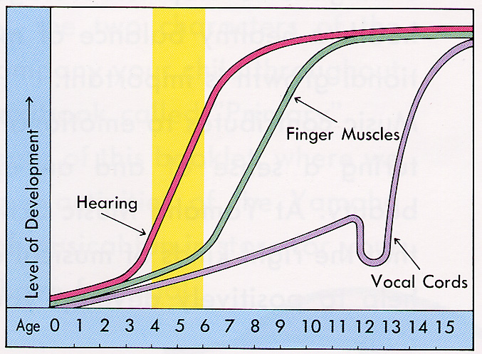
2. Comprehensive Musical Training: Yamaha not only trains its students to be able to perform on an instrument but also develops the fundamentals of good musicianship, such as a good aural (pitch discrimination) and rhythmic sense. Through activities such as singing in Solfege and playing in ensembles, Yamaha develops a well-rounded musician, who will be able to do much more than merely play an instrument.

One of the goals of the Yamaha Music Education System is to develop an appreciation of music as well as the ability to express it. This means:

- Developing sensitivity: A sense of appreciation of all the arts can be developed through music. Yamaha education stresses listening to music and singing with teachers, parents and friends.
- Developing ability: Music fundamentals and playing abilities are developed. This includes:
    - Harmonic ability: the ability to harmonize a given melody. This is one of the building blocks of composition.
    - Ensemble: the ability to play and express music together with others.
    - Reading: reading and writing music and understanding the sounds to be created.
    - Creativity: expressing existing music and creating one’s own music.
    - Singing: interpreting and expressing music through song.
    - Rhythm: feeling and responding to the rhythm of music in a physical way.

3

Yamaha Dealers - GREATER Toronto Area

SCARBOROUGH | P | C | K | G | W | V | D
Long & McQuade 416-439-8001  1133 Markham Rd. |  |  | ✓ | ✓ | ✓ | ✓ | ✓
THORNHILL | P | C | K | G | W | V | D
Yamaha Music Gallery 905-731-7725  100 Steeles Ave. W. | ✓ | ✓ | ✓ | ✓ |  |  | ✓
TORONTO | P | C | K | G | W | V | D
Allegro Music 416-483-7203  2045 Avenue Rd. |  |  | ✓ | ✓ |  |  | ✓
Academy of Music 416-924-7499  499 College St. |  | ✓ | ✓ | ✓ |  |  | ✓
Long & McQuade 416-588-7886  925 Bloor St. W. |  |  | ✓ | ✓ | ✓ | ✓ | ✓
St. John’s Music 416-785-5000  109 Vanderhoof Ave. |  |  | ✓ | ✓ | ✓ |  | ✓
Steve’s Music 416-593-8888  415 Queen St. W. |  |  | ✓ | ✓ |  |  | ✓

Key: P = Acoustic / Disklavier Piano
C = Clavinova (Digital Piano)
K = Portable Keyboard
G = Guitar
W = Woodwinds, Brass
V = Violin (and other Yamaha strings)
D = Drums

Why buy our instruments?
Yamaha founder, Torakusu Yamaha, began producing reed organs in1887! Since that time, Yamaha has developed and manufactured high quality musical instruments. Do you still need another reason? You can use our instrument rebate program to help you pay for group lessons!

40

Yamaha Dealers - GREATER Toronto Area

BRAMPTON | P | C | K | G | W | V | D
Long & McQuade 905-450-4334  108-370 Main St. N. |  |  | ✓ | ✓ | ✓ | ✓ | ✓
ETOBICOKE | P | C | K | G | W | V | D
Kaos Music 416-233-2232  3052 Bloor St. W. |  | ✓ | ✓ | ✓ |  |  | ✓
MISSISSAUGA | P | C | K | G | W | V | D
Toronto Piano 905-361-5664  75 Watline Ave. | ✓ | ✓ | ✓ | ✓ |  |  | ✓
Walters Music 905-896-7766  100 City Centre Dr. (Square One) |  | ✓ | ✓ | ✓
NEWMARKET | P | C | K | G | W | V | D
The Arts 905-898-7164  274 Eagle St. |  |  | ✓ | ✓ |  |  | ✓
NORTH YORK | P | C | K | G | W | V | D
Long & McQuade 416-663-8612  2777 Steeles Ave. W. |  |  | ✓ | ✓ | ✓ | ✓ | ✓
Just Drums 416-226-1211  137 Willowdale Ave. |  |  |  |  |  |  | ✓
OSHAWA | P | C | K | G | W | V | D
Long & McQuade 905-434-1612  902 Simcoe St. N. |  |  | ✓ | ✓ | ✓ | ✓ | ✓
RICHMOND HILL | P | C | K | G | W | V | D
Cosmo Music 905- 770-5222  10 Via Renzo Drive. |  | ✓ | ✓ | ✓ | ✓ |  | ✓

Key: P = Acoustic / Disklavier Piano
C = Clavinova (Digital Piano)
K = Portable Keyboard
G = Guitar
W = Woodwinds, Brass
V = Violin (and other Yamaha strings)
D = Drums

39
    - Developing creativity: through exposure to many styles and facets of music expression, the foundation is laid for developing each student’s creativity.

3. Group Lessons: The advantages of learning in a group are:

- Group lessons are a very effective way to achieve comprehensive musical training. In a group a student can sing with others and perform in various kinds of ensembles.
- In a group there is peer motivation such that a student will want to perform well in front of and with his/her peers. The experience of performing in front of a friendly audience on a regular and frequent basis will give the student confidence and a feeling of accomplishment.
- In a group, pressure is not constantly on one individual. As a result, music skills can be nurtured in a relaxed and friendly environment conducive to learning

4. Systematic Education Programs: Through extensive research and experimentation Yamaha has developed its own materials, including texts and teaching aids, and its own teaching techniques. These materials are constantly being reviewed and upgraded by the Yamaha Music Foundation. In Canada, the Japanese method has been adjusted to adapt to our Western culture. Yamaha instructors are specially trained in the philosophy and methodology of the Yamaha Music Education system at teacher training seminars held on a regular basis.

The Yamaha Method
Applying the underlying philosophy, the Yamaha method of music education incorporates weekly group lessons designed to give students the best beginning possible for the development of basic music skills. Emphasis is placed on ear training and the development of a good rhythmic sense. A variety of activities, including singing words and solfege, keyboard playing, sight singing, sight playing, ensemble work and musical creativity are part of the curriculum. When younger students are accompanied by the parent, as the parent is the essential link between the class experience and successful practice at the home, both child and parent can share the joy of learning music with one another.

4

Music Courses by beginner’s Age
Age* | Instrument | Course | Page
2-3 | ⎯ | Apple Course | 7
3-4 | Keyboard | Music Wonderland | 8
4-5 | Keyboard | Junior Music Course | 9
6 | Keyboard | Young Musicians Course | 14
7 | Keyboard | Young Musicians Course | 14
7 | Guitar | Guitar Primer Course | 22
8-9 | Keyboard | Piano Club | 16
8-9 | Guitar | Guitar Primer Course | 22
8-9 | Violin | Violin Course | 23
8-9 | Flute | Flute Course | 25
8-9 | Cello | Cello Course | 24
9 | Saxophone | Saxophone Course | 26
9 | Choir | Yamaha Choir (no private voice) | 30
10 | Keyboard | Piano Club | 16
10 | Guitar | Guitar Course | 22
10 | Violin | Violin Course | 23
10 | Flute | Flute Course | 25
10 | Saxophone | Saxophone Course | 26
10 | Clarinet | Private Clarinet Lessons | 31
10 | Drums | Drum Course | 27
10 | Voice lessons | Yamaha Choir and/or private | 30
11-17 | Keyboard | Keyboard Club | 17
11-17 | Guitar | Guitar Course | 22
11-17 | Violin | Violin Course | 23
11-17 | Flute | Flute Course | 25
11-17 | Saxophone | Saxophone Course | 26
11-17 | Clarinet | Private Clarinet Lessons | 31
11-17 | Drums | Drum Course | 27
11-17 | Voice lessons | Yamaha Choir | 30
Adult  (18+) | Keyboard | Keyboard Club | 17
Adult  (18+) | Guitar | Guitar Course | 22
Adult  (18+) | Violin | Violin Course | 23
Adult  (18+) | Flute | Flute Course | 25
Adult  (18+) | Saxophone | Saxophone Course | 26
Adult  (18+) | Clarinet | Private Clarinet Lessons | 31
Adult  (18+) | Drums | Drum Course | 27
Adult  (18+) | Voice lessons | Yamaha Choir | 30
Seniors (65+) | Keyboard | Seniors Keyboard Club | 18
*Note: Students must be the above age by October 31 of the academic year.

5
DETERMINING THE MOST  SUITABLE HOME KEYBOARD |  |  | 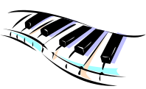
Yamaha Music Courses | Keyboard Required | Tips
Music Wonderland  (3 year old beginners) | OPTIONAL | - Parents may want to plan ahead and purchase a suitable instrument that will last for the next few years  - Example: A Yamaha PSR portable keyboard is best (see Junior Music Course, Years 1 & 2).
Junior Music Course  Years 1 & 2  (4-5 year old beginners) | YES | - Keyboard with full size keys  - Minimum of 61 keys  - Touch sensitivity (the harder you push the key the louder the sound)
Junior Music Course  Years 3 & 4  (6-7 year olds) | YES | - A weighted-key instrument with 88 keys is best  - Example: Yamaha CVP Clavinova, digital or acoustic piano
Junior Advanced Course  (8-9 year old graduates of Junior Music Course) | YES | - A weighted-key instrument with 88 keys is best  - Example: Yamaha CVP Clavinova, digital or acoustic piano
Young Musicians Course  (6-7 year old beginners) | YES | - A full-size keyboard with many sounds is best  - Example: Yamaha PSR portable keyboard or CVP Clavinova
Piano Club  (8-10 year old beginners) | YES | - A weighted-key instrument with 88 keys is best  - Example: Yamaha CLP or CVP Clavinova, digital or acoustic piano
Keyboard Club  (11+ & adult beginners) | YES | - A full-size keyboard with many sounds is best  - Example: Yamaha CLP or CVP Clavinova, digital or acoustic piano

38

PARKING

The parking lot in our building is run by a private company.
Free parking spots are available for above-ground parking and underground parking. At your convenience, there are 600 heated underground parking spaces, perfect for the Winter!

Instructions for Above-Ground Parking:
To park above-ground, spaces are located either in the front or the East of the 169 Enterprise Blvd building (South of Enterprise)
Instructions for Underground Parking:
To park in the underground garage, enter using the ramp located near the East front of the 169 Enterprise Blvd building (South of Enterprise). Please do not park in a “reserved” spot. Yamaha Music School is not responsible for parking violations issued by the building.

Please do not hesitate to contact the school for further parking instructions.

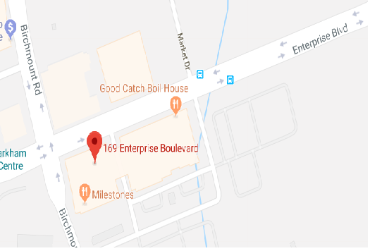

37

REGISTRATION PROCEss: as Easy as 1, 2, 3
1. FIND A CLASS:

Current Students: Returning students receive information explaining registration procedures and dates from their instructors starting in early April.

New Students: Brochures with a full listing of classes and instructor biographies are available in May from the school and on our website.

Payment Method:
- Credit Card: MasterCard, VISA
- Cheque(s): Payable to “Yamaha Canada Music Ltd.”. Note: We charge $20 for dishonored, or NSF cheques.
- Cash: Single payment option only

Note: If registering by phone, we can only accept credit card payments.

Payment Frequency:
- Single Payment:
  - Registration Fee (dated the day of registration),
  - Balance (dated September 1st of the academic year)
- Monthly Payments:
  - Registration Fee (dated the day of registration)
  - First Payment (dated the 1st of the first month of lessons)
  - All Post-Dated Payments (dated the first of each subsequent month, according to the monthly finance plan) – the number of post-dated payments depends on the courses chosen and start dates.

Note: Monthly payments have an additional Finance fee of $3.00
3. REGISTER!

Registration must be completed in person, or by phone to ensure that there is still room in the chosen class. Yamaha Music School must receive full payment (in single or monthly payments) in order for registration to be complete. Yamaha Music School continues to accept registrations until classes are full. Early registration is encouraged to avoid disappointment in the choice of class day and time.

WAITLISTING: It is possible to be put on a waitlist for space in a class that is already full. However, placement on a waitlist is only permitted if registration is made for another class of the same course/level. Waitlisted students are contacted by school administration staff if space becomes available. Waitlists are dissolved on September 30th of the academic year.

For a full list of Yamaha Music School’s Non-Tuition Fees and School Policies, see pages 41-43.
6

APPLE COURSE
Prerequisite | For beginners age 2 by October 31 of the academic year
Lesson Format | 39 weeks, 40-minutes weekly
Maximum Class Size | 10

Course Description:
Two year olds are filled with raw creativity and are without inhibitions, approaching everything with passion and curiosity. When given the right tools to express themselves, watch as their artistic flair takes over. Designed for two year olds, this class enables your toddler to enjoy music the fun way with you. We foster your little one's love for music by teaching them how to 'listen' through fun activities like singing, body movements, and playing with rhythm. It's a great way to spend quality time bonding with your little one.

Performance Level | ⎯
Parent Attendance | Required.
Home Instrument | Optional
Advance to | Junior Music Course (Music Wonderland)
PAYMENT*
Registration Fee | Tuition per Lesson | Total
$60.00 | $13.25 | $576.75
*Please note: The above fees are based on 39 weeks.

Yamaha Instructors
Yamaha instructors are specially trained in the philosophy and methodology of the Yamaha Music Education system at teaching training seminars held on a regular basis.
For more on the Yamaha Method and its underlying philosophy, go to pages 2 to 4.

7

PRACTICE TIPS

We want to make sure that your child succeeds with his/her musical education. Our courses have been designed by educators and child psychologists and although they are a lot of fun, they are designed to create a solid music foundation.
Our teachers are a vital part of your child’s education, but so is at-home practice. As each course progresses, students are expected to practice for a certain length of time and complete homework assignments.
The best advice we can give you is to communicate with your teacher about your child’s progress! Teachers are happy to share their expertise and give parents practical tools to create a positive practice experience.
- Create a good practice environment: Do you have a home instrument? If you do not, then it is not possible for the student to practice every day. Ask the school staff about registered Yamaha dealers in the greater Toronto area, so that you can purchase a home instrument.
- Create the expectation of daily practice at home: A few minutes each day is a good way to start developing discipline and good habits for children as young as 4 years-old in the Junior Music Course.
- Partner in education: For younger children, parents are a vital part of transferring the learning from the classroom to home. Remember to try to include the teacher’s advice at home, like “remember what the teacher said in class? Try it like this…”
- Remain positive: Encourage practice by asking your child “will you finish practicing before dinner, or will you do it before bed?”
- If a pre-school student gets bored soon after beginning to practice, compliment them for trying their best and being willing to try.
- Communicate with your teacher: Observe your child’s progress. Is your child falling behind, or are they willing to move onto harder material? Talk to your teacher about any concerns.
- Ask for help: If practice and homework are a new concept and you are concerned that they may become a struggle, ask your teacher for advice.
- Motivate the end goal without creating shame: Try positive phrasing like “if you keep practicing, you will play better and have more fun playing.”
- Avoid comparing your child’s playing: Instead, use encouragement. If you notice that your child is still struggling after a few weeks, consider signing up for a practice coach.
- Integrate music into your child’s life: For example, visit the Performer’s Club concert as an audience member and ask your child if they would like to sign up for the following month’s concert. Then work with them to practice a piece that they can successfully perform for others.

36

PRACTICE COACH PROGRAM
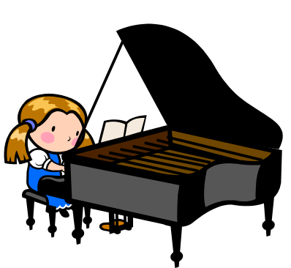
Does your child need help with practice? Book practice time at the Yamaha Music School with a practice coach!
Our coaches are personable teens who are graduates of Yamaha group courses. They are currently taking advanced music studies at our school.
Prerequisite | Enrollment in Junior Music Course, Junior Advanced Course, Young Musicians Course or Piano Club
Lesson Format | 4-session packages, 30-minute session
Maximum Class Size | 1
Skills Developed | Practice coaching sessions follow up skills taught in Junior Music Course, Junior Advanced Course, Young Musicians Course, and Piano Club.
Performance Level | Various
Parent Attendance | Not required
Home Instrument | Required (see course requirement)
Advance to | Continuing (see course requirement)
Single Payment*
Tuition per 30-minute Session |  | Total for 4 Sessions
$14.00 |  | $56.00
*Please Note: A minimum of four (4) practice coaching sessions must be booked and paid for in advance before sessions are scheduled with a practice coach. Yamaha Music School reserves the right to choose and assign the practice coach. Practice coaching fees are only refundable if notice of cancellation is received before the date of the first session.
The private lesson cancellation policy applies to practice coaching sessions cancelled by the student. Please see the Yamaha Music School Policy (pages 41- 42) for more details.

35
MUSIC WONDERLAND
Prerequisite |  | For beginners age 3 by October 31 of the academic year.
Lesson Format |  | Group lessons, 45 minutes weekly
Maximum Class Size |  | 10

Skills Developed
- Listening, Singing, Rhythmic Sense, and Basic Keyboard Techniques.
- These skills are developed according to the heightened aural ability of a 3-year-old student.
- Creative approach centers on developing the three essential elements of pitch, harmony, and rhythm.
Performance Level |  | ⎯
Parent Attendance |  | Required
Home Instrument |  | Optional
Advance to |  | Junior Music Course Year 1
SINGLE PAYMENT*
Registration Fee | Tuition per Lesson |  | Annual Tuition | Total
$100.00 | $19.75 |  | $770.25 | $870.25
MONTHLY FINANCE PLAN*
Registration Fee | First Payment |  | 9 Post-dated payments | Total
$100.00 | $134.25 |  | $74.00 | $900.25
First payment post-dated September 1st and remaining payments post-dated the 1st of each month. The monthly finance option is based on the single payment total plus a finance fee of $3.00 per month.
*Please note: The above fees are based on 39 lessons. Registration and Tuition fees will be pro-rated based on lesson day and start date.

Music makes you smarter!
Music lessons have many advantages: There are studies that show how arts education benefits children. Specifically, music education can increase a child’s spatial intelligence (the ability to envision things that are not concretely in front of you - like maps for geography) by 30 points!

8

JUNIOR MUSIC COURSE
Prerequisite | Year 1: Music Wonderland and/or beginners age 4 to 5 by October 31st of the academic year.  Year 2: Year 1  Year 3: Year 2  Year 4: Year 3
Lesson Format | Group lessons, 60 minutes weekly
Maximum Class Size | 10

Skills Developed
Year 1: Ear Training, Hands-together Keyboard Playing, Ensemble Playing, Singing (solfege and lyrics), Music Appreciation, Rhythmic Sense, Music Reading and Writing. These skills are taught in relation to the rapidly developing aural ability of a 4- or 5-year-old student.
Year 2: Ear Training, Hands-together Keyboard Playing, Ensemble Playing, Singing (solfege and lyrics), Music Appreciation, Rhythmic
Sense, Keyboard Harmony, Music Reading and Writing. These skills are taught in relation to the rapidly developing aural and fine motor abilities of a 5- or 6-year-old student.
Year 3: Keyboard Performance, Note and Rhythm Reading, Ensemble Playing, Solfege Singing, Accompaniment and Arranging, Ear training, Music Writing and Creativity. These skills are taught in relation to the greater motor skills and reading ability of a 6- or 7-year-old student.
Year 4: Keyboard Performance, Note and Rhythm Reading, Ensemble Playing, Solfege Singing, Accompaniment and Arranging, Ear Training, Composition, Music Writing and Creativity. These skills are taught
in relation to the greater motor skills and reading ability of a
7- or 8-year-old student.
Performance Level | Year 1: ⎯  Year 2: Students are prepared to take the optional Fundamental Skills Survey, which evaluates musicianship skills at the end of JMC2.  Year 3: Yamaha Grade 10 exam  Year 4: Yamaha Grade 9 exam
Parent Attendance | Year 1/2: Required  Year 3/4: Recommended, but not mandatory (at the teacher’s discretion)
Home Instrument | Year 1/2: A keyboard with full size keys is required  Year 3/4: A digital or acoustic piano is required
Advance to | Year 1: Year 2  Year 2: Year 3  Year 3: Year 4  Year 4: Junior Advanced Course Year 1

9

Why do we use keyboard instruments?
The use of the keyboard as a learning tool is one characteristic of the Yamaha Music Education System. Keyboards offer the following advantages:
- Pitch Accuracy: When a key is pressed, it produces the correct sound.
- All Musical Elements: Students can play melody, rhythm, and harmony on one instrument.
- Visible & Touchable: On a keyboard, notes are easy to find and play.
- Range: Sounds in all ranges (high and low) are easy to produce.

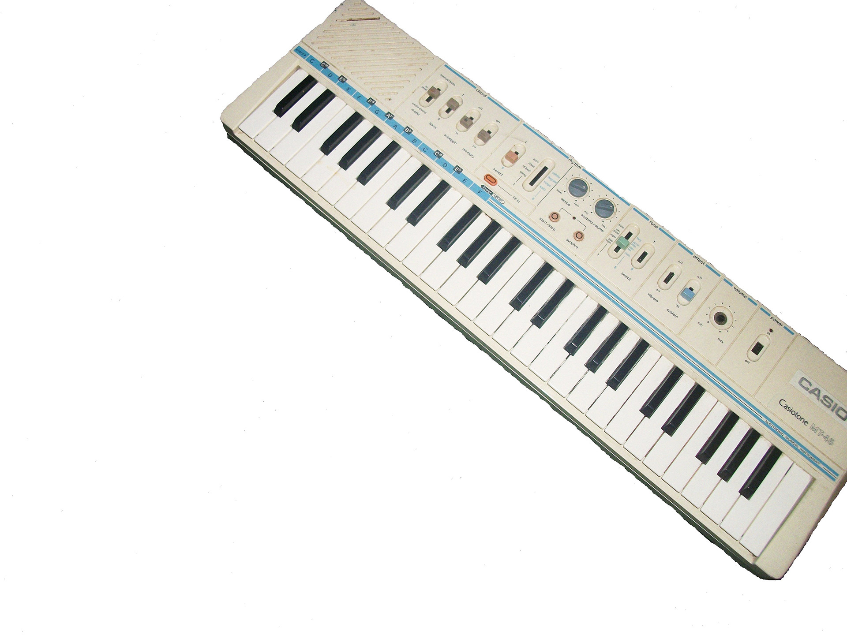

34

STUDIO RENTAL
Looking for a place to practice right before your lesson?  Need to use a specific keyboard?  Why not rent a studio at the Yamaha Music School? |  |  | 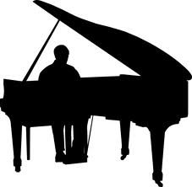
RENTAL RATES* | Yamaha student | Non-Yamaha student
1 studio, 1 person (solo) | - $10.00 / hour  (HST included) (1/2-hour min. charge) | - $20.00/hour  (HST included)  (1-hour min. charge)
1 studio, 2 persons (duet) | - $20.00/hour  (1-hour min. charge HST included) | - $40.00/hour  (HST included)  (1-hour min. charge)
Small Groups  (4 or 5 persons) | - $80.00 (HST included)
*Cash only. Based on studio availability.
Guidelines:
Only piano, electronic keyboard or digital piano available for non-Yamaha students, based on availability, unless prior arrangements are made with the school manager. Piano, electronic keyboard, digital piano, Electone, guitar or drums available for Yamaha students, based on availability.
No advance reservations permitted except for groups (3+ persons) with prior approval of the school manager.
If rental involves both Yamaha and non-Yamaha students, the non-Yamaha rate applies.
No additional persons permitted in studios during rental.

Practice studios cannot be rented for teaching/coaching purposes.

Note: Persons not abiding by these guidelines will have their practice session terminated without refund.

33

SINGLE PAYMENT*
Registration Fee Concert Fee Tuition per Lesson Annual Tuition Total
Year 1 | $120.00 |  | $26.50 |  | $26.50 |  | $1,033.50 |  | $1,180.00
Year 2 | $120.00 |  | $26.50 |  | $26.50 |  | $1,033.50 |  | $1,180.00
Year 3 | $110.00 |  | $27.00 |  | $27.00 |  | $1,053.00 |  | $1,190.00
Year 4 | $110.00 |  | $27.00 |  | $27.00 |  | $1,053.00 |  | $1,190.00
MONTHLY FINANCE PLAN*
Registration Fee First Payment 9 Post-dated payments Total
Year 1 |  | $120.00 |  | $190.00 |  | $100.00 |  | $1210.00
Year 2 |  | $120.00 |  | $190.00 |  | $100.00 |  | $1210.00
Year 3 |  | $110.00 |  | $210.00 |  | $100.00 |  | $1220.00
Year 4 |  | $110.00 |  | $210.00 |  | $100.00 |  | $1220.00
First payment post-dated September 1st and remaining payments post-dated the 1st of each month. The monthly finance option is based on the single payment total plus a finance fee of $3.00 per month.
*Please note: The above fees are based on 39 lessons. Registration and Tuition fees will be pro-rated based on lesson day and start date.

Why Group Lessons?
Students of all ages learn better in groups due to the following factors:
- Peer Influence
- Motivation from more than one source
- More facets of learning (e.g. ensemble playing)
- Pressure is not always on the same individual

10

JUNIOR ADVANCED COURSE
Prerequisite |  |  | Year 1: Junior Music Course Year 4 or Young Musicians Course Year 3  Year 2: Year 1  Year 3: Year 2  Year 4: Year 3
Lesson Format |  |  | Group classes, 60 minutes weekly
Maximum Class Size |  |  | 10

Skills Developed
- Group Lessons: Keyboard Harmony; Solfege Singing; Ensemble playing; Accompaniment and Arranging; Improvisation; Composition; Ear Training; Music Reading and Writing
- These skills are taught in relation to the performance, intellectual, and creative abilities of an 8-, 9-, or 10- year-old student.
Performance Level |  |  | Year 1: Between Yamaha Grade 9 - 8  Year 2: Yamaha Grade 8 exam  Year 3: Between Yamaha Grade 8 and 7
Parent Attendance |  |  | Not mandatory (at the teacher’s discretion)
Home Instrument |  |  | A digital or acoustic piano is required
Advance to |  |  | Year 1: Year 2  Year 2: Year 3  Year 3: Year 4  Year 4: Private lessons
SINGLE PAYMENT*
Registration Fee Concert Fee Tuition per Lesson Annual Tuition Total
Per Year | $70.00 |  | $27.50 |  | $27.50 |  | $1072.50 |  | $1,170.00
MONTHLY FINANCE PLAN*
Registration Fee First Payment 9 Post-dated payments Total
Per Year |  | $70.00 |  | $185.00 |  | $105.00 |  | $1200.00
First payment post-dated September 1st and remaining payments post-dated the 1st of each month. The monthly finance option is based on the single payment total plus a finance fee of $3.00 per month.
*Please note: The above fees are based on 39 lessons. Registration and Tuition fees will be pro-rated based on lesson day and start date.

11

ADVANCED Monthly Finance Plan*¹
Duration Registration Fee First Payment 9 Post-dated payments Total
30 | $55.00 |  |  | $234.00 | $155.00 |  | $1,725.00
45 | $55.00 |  |  | $336.00 | $232.50 |  | $2,483.50
60 | $55.00 |  |  | $438.00 | $310.00 |  | $3283.00
*Please note: The above fees are based on 40 lessons. Registration and Tuition fees will be pro-rated based on lesson day and start date.
¹Please note: First payment post-dated Sept. 1st and remaining payments post-dated the 1st of each month. Monthly finance option is based on single payment total plus finance fee of $3.00 per month.
yAMAHA gRADE eXAMINATION SYSTEM
The Yamaha Grade Examination System was started in 1967 for the purpose of enabling everyone who is learning music to improve their musical skills in a well-planned manner, while verifying their overall ability.
More than 10 million people have taken these proficiency examinations over the past 40 years, and this system is widely accepted as the standard for assessing musical abilities. The Grade Examination System targets two groups: students and teachers.

Student grades are used as an objective assessment of the progress being made in learning music, while the teacher grades certify the performance ability as well as overall musical knowledge needed to provide music instruction.

The grade exam system is designed to examine performance abilities and general music knowledge, both of which are necessary for enjoying music, teaching music fundamentals and playing professionally.

Students taking private lessons at Yamaha Music School are encouraged to continue taking Yamaha Grade Exams, as these are recognized world-wide.

31

32

PRIVATE LESSONS
Prerequisite |  |  | Graduates of Yamaha group programs, or by assessment if new student has 1 years’ experience elsewhere.  Note: Voice students must be age 10+
Lesson Duration |  |  | 30 minutes, 45 minutes, or 60 minutes
Lesson Format |  |  | Weekly lessons
Instruments |  |  |  |  |  | Styles
Piano / Keyboard Violin Clarinet  Electone Cello Drums  Guitar Sax/ Flute Theory |  |  |  |  |  | Classical, Popular, Jazz, Rock, & others
Level |  | Yamaha Grade |  |  |  | RCM Grade
Elementary |  | Student Grades 9 - 8 |  |  |  | 1 - 5
Intermediate |  | Student Grades 7 - 6 |  |  |  | 6 - 8
Advanced |  | Instructor Grades 5 - 3 |  |  |  | 9,10 & Diploma
WEEKLY LESSONS
ELEMENTARY Single Payment*
Duration Registration Fee Tuition per Lesson Annual Tuition Total
30 | $55.00 |  |  | $31.00 | $1240.00 |  | $1295.00
45 | $55.00 |  |  | $46.50 | $1,860.00 |  | $1,915.00
60 | $55.00 |  |  | $62.00 | $2,480.00 |  | $2,535.00
ELEMENTARY Monthly Finance Plan*¹
Duration Registration Fee First Payment 9 Post-dated payments Total
30 | $55.00 |  |  | $235.00 | $115.00 |  | $1,325.00
45 | $55.00 |  |  | $405.00 | $165.00 |  | $1,945.00
60 | $55.00 |  |  | $485.00 | $225.00 |  | $2,565.00
INTERMEDIATE Single Payment*
Duration Registration Fee Tuition per Lesson Annual Tuition Total
30 | $55.00 |  |  | $36.00 | $1,440.00 |  | $1,495.00
45 | $55.00 |  |  | $54.00 | $2,160.00 |  | $2,215.00
60 | $55.00 |  |  | $72.00 | $2,880.00 |  | $2,935.00
INTERMEDIATE Monthly Finance Plan*
Duration Registration Fee First Payment 9 Post-dated payments Total
30 | $55.00 |  |  | $255.00 | $135.00 |  | $1,525.00
45 | $55.00 |  |  | $435.00 | $195.00 |  | $2,245.00
60 | $55.00 |  |  | $525.00 | $265.00 |  | $2,965.00
ADVANCED Single Payment*
Duration Registration Fee Tuition per Lesson Annual Tuition Total
30 | $55.00 |  |  | $41.00 | $1,640.00 |  | $1,695.00
45 | $55.00 |  |  | $61.50 | $2,460.00 |  | $2,515.00
60 | $55.00 |  |  | $82.00 | $3,198.00 |  | $3,253.00
31

JUNIOR SPECIAL ADVANCED COURSE
Prerequisite |  | Year 1: Junior Music Course Year 2 with successful audition and parent meeting  Year 2: Year 1  Year 3: Year 2
Lesson Format |  | Year 1/2: Group classes, 60 minutes weekly and Private lessons, 30 minutes weekly, both to be taken at Yamaha Music School  Year 3: Group classes, 90 minutes weekly and Private lessons, 45 or 60 minutes weekly, both to be taken at Yamaha Music School
Maximum Class Size |  | 10

Skills Developed: □ Group Lessons: Solfege Singing, Ear Training, Keyboard Harmony, Ensemble Playing, Improvisation, Composition
□ Private Lessons: Piano Performance, Sight-reading
These skills are taught in relation to the greater motor, creative and reading skills of exceptional 6- to 10-year-old students.
Performance Level |  | Year 1: Yamaha Grade 9 (required exam)  Year 2: Yamaha Grade 8 (required exam)  Year 3: Yamaha Grade 7 (required exam)
Parent Attendance |  | Year 1/ 2: Recommended but not mandatory (at the teacher’s discretion)  Year 3: Not mandatory- at teacher’s discretion
Home Instrument |  | A digital piano or acoustic piano is required
Advance to |  | Year 1: Year 2  Year 2: Year 3  Year 3: Senior Advanced Course
SINGLE PAYMENT* Registration Fee Tuition per Lesson** Annual Tuition Total
Year 1 + P30 | $120.00 |  | $74.50 | $2,905.50 | $3,025.50
Year 2 + P30 | $120.00 |  | $74.50 | $2,905.50 | $3,025.50
Year 3 + P45 | $80.00 |  | $100.00 | $3,900.00 | $3,980.00
MONTHLY FINANCE PLAN*
Registration Fee First Payment 9 Post-dated payments Total
Year 1 + P30 | $120.00 |  | $460.50 | $275.00 | $3,055.50
Year 2 + P30 | $120.00 |  | $460.50 | $275.00 | $3,055.50
Year 3 + P45 | $80.00 |  | $645.00 | $365.00 | $4010.00
First payment post-dated September 1st and remaining payments post-dated the 1st of each month. The monthly finance option is based on the single payment total plus a finance fee of $3.00 per month.

*Please note: The above fees are based on 39 lessons. Registration and Tuition fees will be pro-rated based on lesson day and start date.
**Tuition per lesson is the total of one weekly group lesson plus one weekly private lesson.
12
Creating Creative thinkers
In order to enable students to develop their creative capabilities, it is important to help them develop the ability to express themselves by thinking freely.
Yamaha’s comprehensive system of music education aims to help students acquire and enhance sensitivity and imagination, both of which are sources of creativity.
Once students have developed music fundamentals like pitch, harmony and rhythm, we work on accompaniment and improvisation.
The ability to create original compositions is unique to Yamaha Music Education System.
In today’s changing world, the ability to think creatively is an essential skill. The ability to improvise music is essentially creative problem-solving!

13

YAMAHA ORCHESTRA
Prerequisite |  | Minimum 1 year of study on chosen instrument (viola, violin, cello, guitar, drums, etc)  For all ages including adults
Lesson Format |  | * 5 rehearsals from September to December  * 10 rehearsals from January to June  * Schedule to be confirmed in early September  * Duration of each rehearsal: 90 minutes
Maximum Class Size |  | 25
Instruments |  | Strings, Woodwinds, Percussion

Skills Developed:
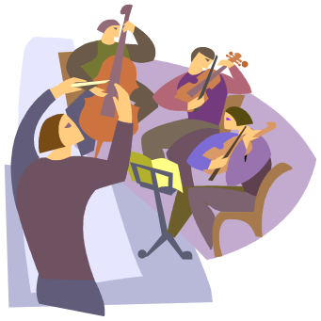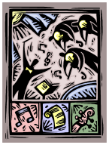

Listening

Ensemble Playing

Reading

Expressivity

Functioning in an orchestral setting

Home Instrument |  | Required
SINGLE PAYMENT – Fall session (5 rehearsals)
Registration  Fee | Fall Session Tuition –  $5 Yamaha Student |  | Fall Session Tuition –  $10 Non-Yamaha Student
NONE | $25.00 |  | $50.00
SINGLE PAYMENT – Winter/Spring session (10 rehearsals)
Registration  Fee | Winter/Spring Session Tuition –  $5 Yamaha Student |  | Winter/Spring Session Tuition –  $10 Non-Yamaha Student
NONE | $50.00 |  | $100.00

There are no refunds/credits upon withdrawal from the Yamaha Orchestra after the date of the first lesson except due to illness (a physician’s letter must be provided).

30

Performer’s Club

Performers Club is a program Yamaha Music School students of any age and level. Members get the opportunity to perform in public, meet new friends, and share their love of music in one of two ways:
Perform in the Yamaha Performance Concert Series
Develop your own music-related project.
The membership is only $25 per year and allows the student to perform in approximately one concert each month. Concert dates are posted at the school each month.

Club Members meet approximately once each month to perform for friends and family in a safe, encouraging setting.
The club is a good idea for:
private students who enjoy performing;
students use performance dates as incentive to practice
students who would like to perform in a safe setting before a competition.

29

YOUNG MUSICIANS COURSE
Prerequisite | Year 1: For beginners age 6 & 7 years old by October 31st of the academic year.  Year 2: Year 1  Year 3: Year 2
Lesson Format | Group lessons, 60 minutes weekly
Maximum Class Size | Year 1: 10  Year 2: 10  Year 3: 10

Skills Developed
Year 1: Keyboard Performance; Singing (solfege and lyric); Ensemble Performance; Creativity; Ear Training; Note and Rhythm Reading. Repertoire utilizes the features of electronic keyboards and the imaginatively themed titles help promote expressive performance.
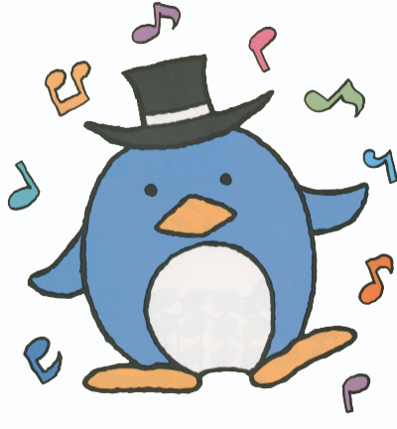
Year 2: Primary focus is still keyboard performance. Singing (solfege and lyric), creativity and ear training continue. Greater emphasis is placed on note/rhythm reading and ensemble playing to reflect the student’s intellectual abilities and independence.
Year 3: Primary focus is still keyboard performance with an increased focus on traditional piano repertoire. Ensemble, creativity and ear training continue. Solfege singing is now used mainly to develop reading skills as students become fully independent.
Performance Level | Year 1: Yamaha Grade 12 (unofficial exam)  Year 2: Yamaha Grade 10 exam  Year 3: Yamaha Grade 9 exam
Parent Attendance | Year 1: Required  Year 2: Recommended but not mandatory (at the teacher’s discretion)  Year 3: Optional
Home Instrument | An electronic or acoustic keyboard with full size keys is required
Advance to | Year 1: Year 2  Year 2: Year 3  Year 3: Junior Advanced Course Year 1 and/or Private Lessons

14

SINGLE PAYMENT*
Registration Fee Concert Fee Tuition per Lesson Annual Tuition Total
Year 1 | $105.00 |  | $26.50 |  | $26.50 |  | $1,033.50 |  | $1,165.00
Year 2 | $105.00 |  | $27.00 |  | $27.00 |  | $1,053.00 |  | $1,185.00
Year 3 | $105.00 |  | $27.00 |  | $27.00 |  | $1,053.00 |  | $1,185.00
MONTHLY FINANCE PLAN*
Registration Fee First Payment 9 Post-dated payments Total
Year 1 |  | $105.00 |  | $190.00 |  | $100.00 |  | $1,195.00
Year 2 |  | $105.00 |  | $210.00 |  | $100.00 |  | $1,215.00
Year 3 |  | $105.00 |  | $210.00 |  | $100.00 |  | $1,215.00
First payment post-dated September 1st and remaining payments post-dated the 1st of each month. The monthly finance option is based on the single payment total plus a finance fee of $3.00 per month.
*Please note: The above fees are based on 39 lessons. Registration and Tuition fees will be pro-rated based on lesson day and start date.

15

MUSIC THEORY
Prerequisite |  | Please consult the RCM Examination Syllabus  Students are responsible for registering for the exam session themselves.
Lesson Format |  | Summer Theory: Group lessons, 150 minutes  (2 ½ hours) twice each week  Fall Theory: Group lessons, 60 minutes weekly
Maximum Class Size |  | 10

Skills Developed
Theory courses are group lessons designed to complete the requirements of the RCM Theory Exams.
Theory includes: Basic Rudiments, Intermediate Rudiments, Advanced Rudiments
Advanced Theory includes: Basic Harmony, History 1 – An Overview, Intermediate Harmony, History 2 – Middle Ages to Classical
Performance Level |  | Summer courses prepare students for the summer session RCM exam in August.  Fall courses prepare students for the spring session RCM exam in May.
Parent Attendance |  | Not required
Home Instrument |  | Not required
Advance to |  | Please consult the RCM Examination Syllabus
SINGLE PAYMENT  Registration Fee |  |  | Tuition per Lesson | Annual Tuition | Total
SUMM Theory* | $55.00 |  | $41.00 | $451.00 | $506.00
SUMM Theory A* | $55.00 |  | $43.00 | $473.00 | $528.00
Theory** | $55.00 |  | $21.50 | $838.50 | $893.50
Theory Adv** | $55.00 |  | $26.50 | $795.00 | $850.00

MONTHLY FINANCE PLAN
Registration Fee First Payment 8 Post-dated payments Total
Theory** | $55.00 |  | $148.50 | $80.00 | $923.50
Theory Adv** | $55.00 |  | $152.00 | $80.00 | $847.00
First payment post-dated September 1st and remaining payments post-dated the 1st of each month. The monthly finance option is based on the single payment total plus a finance fee of $3.00 per month.
*Please note: The above fees are based on 11 lessons. Registration and Tuition fees will be pro-rated based on lesson day and start date.
**Please note: The above fees are based on 30 lessons. Registration and Tuition fees will be pro-rated based on lesson day and start date.
28

DRUM COURSE
Prerequisite |  | Year 1: For beginners age 10 & up, including adults, by October 31st of the academic year.  Year 2: Year 1
Lesson Format |  | Group lessons, 60 minutes weekly  Classes are organized according to age groups
Maximum Class Size |  | 8

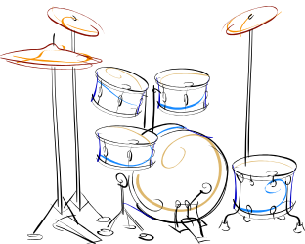
Skills Developed
- A wide variety of Musical styles from Pop/Rock to Jazz
- A wide variety of motivating repertoire
- Ensemble Performance (“JAM” sessions)
- Relevant exercises and drills (with floppy disk accompaniment) necessary for the training of technical skills
- Music knowledge
- Effective use of the instrument(s)
Performance Level |  | ―
Parent Attendance |  | Not required
Home Instrument |  | Minimum: drum pad and sticks
Advance to |  | Year 1: Year 2  Year 2: Group or Private Lessons
SPECIAL OFFER: Drum course registration fee includes one practice pad and one pair of drum sticks (available in the first lesson of year 1).

SINGLE PAYMENT*  Registration Fee |  |  | Tuition per Lesson | Concert Fee |  | Annual Tuition | Total
Year 1 | $75.00 |  | $26.50 | $26.50 |  | $1,033.50 | $1,135.00
Year 2 + | $65.00 |  | $26.50 | $26.50 |  | $1,033.50 | $1,125.00

MONTHLY FINANCE PLAN*
Registration Fee First Payment 9 Post-dated payments Total
Year 1 | $75.00 |  | $190.00 |  | $100.00 |  | $1,165.00
Year 2 + | $65.00 |  | $190.00 |  | $100.00 |  | $1,155.00
First payment post-dated September 1st and remaining payments post-dated the 1st of each month. The monthly finance option is based on the single payment total plus a finance fee of $3.00 per month.
*Please note: The above fees are based on 39 lessons. Registration and Tuition fees will be pro-rated based on lesson day and start date.

27

PIANO CLUB
Prerequisite |  |  | Year 1: For beginners age 8 to 10 by  October 31st of the academic year.  Year 2: Year 1
Lesson Format |  |  | Group lessons, 60 minutes weekly
Maximum Class Size |  |  | 10

Skills Developed
Year 1: Piano Performance, Solfege Singing; Ensemble Performance; Creativity; Ear Training. As this course is geared to an older beginner, reading skills are emphasized from the start.
Year 2: Comprehensive skills learned in Piano Club 1 continue at a more advanced level.
Performance Level |  |  | Year 1: Yamaha Grade 11 (unofficial exam)  Year 2: Yamaha Grade 10 exam / (RCM Grade 1-2 approximately)
Parent Attendance |  |  | Year 1: Recommended  Year 2: Optional
Home Instrument |  |  | An instrument with weighted keys such as an acoustic or digital piano is required
Advance to |  |  | Year 1: Year 2  Year 2: Private lessons
SINGLE PAYMENT*
Registration Fee Concert Fee Tuition per Lesson Annual Tuition Total
Year 1 | $75.00 |  | $26.50 |  | $26.50 |  | $1,033.50 |  | $1,135.00
Year 2 | $75.00 |  | $26.50 |  | $26.50 |  | $1,053.00 |  | $1,155.00
MONTHLY FINANCE PLAN*
Registration Fee First Payment 9 Post-dated payments Total
Year 1 |  | $75.00 |  | $190.00 |  | $100.00 |  | $1,165.00
Year 2 |  | $75.00 |  | $210.00 |  | $100.00 |  | $1,185.00
First payment post-dated September 1st and remaining payments post-dated the 1st of each month. The monthly finance option is based on the single payment total plus a finance fee of $3.00 per month.
*Please note: The above fees are based on 39 lessons. Registration and Tuition fees will be pro-rated based on lesson day and start date.

16
KEYBOARD CLUB
Prerequisite |  |  | Year 1: For beginners age 11 & up, including adults by October 31st of the academic year.  (Classes grouped by age)  Year 2: Year 1
Lesson Format |  |  | Group lessons, 60 minutes weekly  Classes are organized according to age groups
Maximum Class Size |  |  | 10

Skills Developed
Year 1: Electronic Keyboard Performance; Theory; Technique;
Ensemble Performance. Students utilize technology to learn arranging
and creative skills.
Year 2: Skills taught in year one are further developed at a more
advanced level.
Performance Level |  |  | ―
Parent Attendance |  |  | Not required
Home Instrument |  |  | An electronic or acoustic keyboard with full size keys is required
Advance to |  |  | Year 1: Year 2  Year 2: Private lessons
SINGLE PAYMENT*
Registration Fee Concert Fee Tuition per Lesson Annual Tuition Total
Year 1 | $60.00 |  | $26.50 |  | $26.50 |  | $1,033.50 |  | $1,120.00
Year 2 | $60.00 |  | $27.00 |  | $27.00 |  | $1,053.00 |  | $1,140.00
MONTHLY FINANCE PLAN*
Registration Fee First Payment 9 Post-dated payments Total
Year 1 |  | $60.00 |  | $190.00 |  | $100.00 |  | $1,150.00
Year 2 |  | $60.00 |  | $210.00 |  | $100.00 |  | $1,170.00
First payment post-dated September 1st and remaining payments post-dated the 1st of each month. The monthly finance option is based on the single payment total plus a finance fee of $3.00 per month.
*Please note: The above fees are based on 39 lessons. Registration and Tuition fees will be pro-rated based on lesson day and start date.

17

SAXOPHONE COURSE
Prerequisite |  | Year 1: For beginners age 9 & up, including adults, by October 31st of the academic year.  Year 2: Year 1  Year 3: Year 2
Lesson Format |  | Group lessons, 60 minutes weekly  Classes are organized according to age groups
Maximum Class Size |  | 8

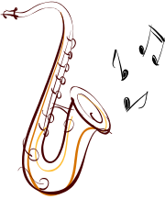
Skills Developed
- A wide variety of Musical styles from Pop/Rock to Jazz
- A wide variety of motivating repertoire
- Ensemble Performance (“JAM” sessions)
- Relevant exercises and drills (with floppy disk accompaniment) necessary for the training of technical skills
- Music knowledge
- Effective use of the instrument(s)
Performance Level |  | ―
Parent Attendance |  | Not required
Home Instrument |  | Required
Advance to |  | Year 1: Year 2  Year 2: Year 3  Year 3: Group or Private Lessons
SINGLE PAYMENT*  Registration Fee |  |  | Tuition per Lesson | Concert fee |  | Annual Tuition
Per Year | $65.00 |  | $26.50 | $26.50 |  |  | $1,033.50 | $1,125.00

MONTHLY FINANCE PLAN*
Registration Fee First Payment 9 Post-dated payments Total
Per Year | $65.00 |  | $190.00 |  | $100.00 |  |  | $1,155.00
First payment post-dated September 1st and remaining payments post-dated the 1st of each month. The monthly finance option is based on the single payment total plus a finance fee of $3.00 per month.
*Please note: The above fees are based on 39 lessons. Registration and Tuition fees will be pro-rated based on lesson day and start date.

26

FLUTE COURSE
Prerequisite |  | Year 1: For beginners age 8 & up, including adults, by October 31st of the academic year.  Year 2: Year 1  Year 3: Year 2
Lesson Format |  | Group lessons, 60 minutes weekly  Classes are organized according to age groups
Maximum Class Size |  | 8
Skills Developed |  | - Students are taught the proper breathing and fingering techniques,  - Variety of flute repertoire, in a relaxed and fun atmosphere.
Performance Level |  | ―
Parent Attendance |  | Not required
Home Instrument |  | Required
Advance to |  | Year 1: Year 2  Year 2: Year 3  Year 3: Group or Private lessons
SINGLE PAYMENT*
Reg Fee Tuition per Lesson Concert fee Annual Tuition Total
Per Year | $65.00 |  | $26.50 |  | $26.50 |  | $1,033.50 |  | $1,125.00
MONTHLY FINANCE PLAN*
Registration Fee First Payment 9 Post-dated payments Total
Per Year | $65.00 |  |  | $190.00 |  | $100.00 |  | $1,155.00
First payment post-dated September 1st and remaining payments post-dated the 1st of each month. The monthly finance option is based on the single payment total plus a finance fee of $3.00 per month.
*Please note: The above fees are based on 39 lessons. Registration and Tuition fees will be pro-rated based on lesson day and start date.

25

SENIORS KEYBOARD CLUB
Prerequisite |  | For adults age 60 & up
Lesson Format |  | 10-lesson modules, 60 minutes weekly
Maximum Class Size |  | 12

Skills Developed
- Keyboard Playing; Music Appreciation; Rhythmic Sense; Music Reading and Writing; Ear Training.
- Play and enjoy a wide variety of music.
- Promote health and make new friends in a relaxed and enjoyable atmosphere.
Performance Level |  | —
Home Instrument |  | A keyboard with full size keys is required
Advance to |  | Additional modules or private lessons
PAYMENT*

The first 4 lessons are FREE! (See policy for details)
Subsequent modules cost: $150.00 flat rate
Registration Fee | Tuition per Lesson |  | First module  (based on 4 free) | Subsequent modules
$0.00 | $15.75 |  | $94.50 | $157.50
*Note: The above fees are based on 10 lessons. Tuition fees will be pro-rated based on lesson day and start date. There are no refunds/credits upon withdrawal from the Seniors Keyboard Club Course after the date of the first lesson except due to illness (a physician’s letter must be provided).

SENIORS KEYBOARD CLUB POLICY
First-time students are eligible for free SKC lessons (see above) if they are a new Yamaha student at time of registration.
Students may not carry forward any free lessons to a future module.
Seniors age 60+ who are registering for their first module of SKC receive free lessons if they register before the module starts. If Seniors age 60+ register after the start of their first module, they have two options: a) register, start attending SKC immediately and receive the free lessons free (no carryover of free lessons to future modules); b) register and wait until the start of the next available module and receive the free lessons.

18

SENIORS KEYBOARD CLUB POLICY, continued
Seniors may register and pay for a partial module (any number of lessons less than 10), provided they start attending from the beginning of that module without skipping any consecutive lessons thereafter. The cost will be pro-rated (number of lessons at the 1/10 module rate, plus any other applicable charges - registration, parking, etc.).
Seniors may not register and pay for only the first and last parts of a module and be absent for the middle part of a module. (Lessons charged are from the first day registered to the end of the module. There are no credits for lessons missed within the module).
Seniors who feel their current SKC class is progressing too quickly or slowly may request to move at any time to a different SKC class that may better suit their level (provided an appropriate SKC class is available at a convenient time and the instructor approves).
If there is no suitable class at the time of the transfer request, and if this is during the senior's free lesson module, free lessons may not be carried forward to a future module if the senior prefers not to continue with a currently available class.

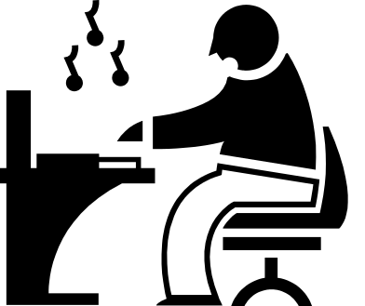

19

VIOLIN COURSE
Prerequisite |  |  |  | Year 1: For beginners age 8 & up, including adults, by October 31st of the academic year.  Year 2: Year 1  Year 3: Year 2
Lesson Format |  |  |  | Group lessons, 60 minutes weekly  Classes are organized according to age groups
Maximum Class Size |  |  |  | 8

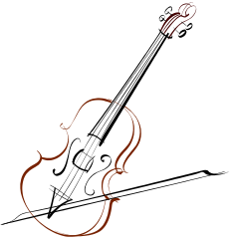
Skills Developed
- Fundamentals Training; Note Reading; Ear Training; Soloing; Accompaniment / Ensemble Playing
- A variety of styles and techniques from classical to folk are taught in a relaxed and fun atmosphere.
- Students are introduced to proper fiddle technique with an emphasis on Canadian regional folk style.
Performance Level |  |  |  | ―
Parent Attendance |  |  |  | Not required
Home Instrument |  |  |  | Required
Advance to |  |  |  | Year 1: Year 2  Year 2: Year 3  Year 3: Group or Private lessons
SINGLE PAYMENT*
Reg Fee Tuition per Lesson Concert Fee Annual Tuition Total
Per Year | $65.00 |  | $26.50 |  |  | $26.50 | $1,033.50 | $1,125.00
MONTHLY FINANCE PLAN*
Registration Fee First Payment 9 Post-dated payments Total
Per Year |  | $65.00 |  |  | $190.00 |  | $100.00 | $1,155.00
First payment post-dated September 1st and remaining payments post-dated the 1st of each month. The monthly finance option is based on the single payment total plus a finance fee of $3.00 per month.
*Please note: The above fees are based on 39 lessons. Registration and Tuition fees will be pro-rated based on lesson day and start date.

24

REFER A FRIEND PROGRAM
Yamaha Music School appreciates your referrals. We would like to thank you for your referral by giving you a special “Yamaha Music School Gift”.
Referral guidelines:
- Both referral and referee will receive a $40.00 credit towards the current school years tuition.
- New student cannot be related or living at the same address.
- Both students must maintain their school accounts in good standing.
- UNLIMITED REFERRALS!

Please call or visit the front desk for more information!

Sharing our stories
Yamaha Music School has been part of the Toronto community for almost thirty years. Our students have grown up with us and in turn, brought their own children for their music education.

We try to communicate school information to our parents and students. Our website www.yamahamusicschool.ca is a great place to check for new courses, summer programs, school closures or holiday reminders.

Our website has a testimonial page, so we would love to hear your “music school” story. Simply tell us how your instructor, the staff or the Yamaha Music Education System has affected your life at school@yamaha.ca. We would be happy to spotlight your experience on our website’s testimonial page!

Several times each year we also have an electronic newsletter. Do you have a newsletter idea? Email us at school@yamaha.ca

23

CLASS EXPECTATIONS & BEHAVIOUR
We expect our classes to be safe learning spaces, and we need everyone to cooperate to make this possible.

Group Class expectations:
- First and foremost, we expect all students, parents and teachers to treat each other with respect and consideration.
- Instructors are responsible for reminding students of appropriate behavior in class. If there are disagreements or classroom management issues, these should be discussed with the teacher, who is responsible for this area.
- One parent/guardian is expected to accompany the student every class, unless otherwise noted.
- Phones/ tablets are not to be used in class, except for taking homework notes at the end of the lesson. Phones/ tablets are disruptive and undermine the parent’s role in class.
- Phones should be turned off, or turned to silent mode. Answering calls, or even leaving the class to answer a call is disruptive.
- Parents’ role in class is to observe the class so as to support the student’s at-home practice. Excessive talking, coaching or over-explaining is also disruptive. The teacher can help explain in another way, if needed.
- Students are expected to practice a minimum of 15 to 20 minutes each day at home. It is helpful if parents sit beside their child during practice time to encourage them and ensure appropriate practice.

20

Popular Music Courses
Yamaha Music School is proud to offer Popular Music Courses. These courses are offered in over 2,300 locations worldwide and are certainly popular, with over 140,000 students currently enrolled in Yamaha schools around the world!
What makes our courses special?
The Popular Music Courses are specifically designed for adolescents though adults, and, like other Yamaha courses, students follow a systematic program that is based on proven education principles.
Our group classes provide a supportive environment where students play and learn contemporary music together, making Popular Music Courses engaging and fun.
At Yamaha Music School we offer a great variety of Popular Music Courses ranging from guitar, drums, clarinet, flute, saxophone, as well as violin and cello.
Students can learn to play an instrument with a set group class of students that are in their age-range and have similar ability.
At the end of most of the PMC courses, students will participate in a public concert at the Mel Lastman Square Amphitheatre, where they can showcase the skills they have acquired throughout the year. It’s a great way to end the school year and welcome the summer. Yet the fun does not end there!
After one full year of lessons, students can also enroll in the Yamaha Music School Orchestra, Ensemble Course, Jazz Jam, or during the summer, play in the Rock Band!
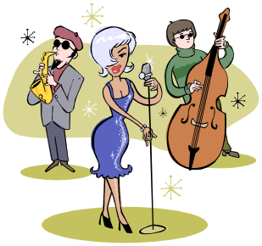

21

GUITAR COURSE
Prerequisite |  |  | Year 1: For beginners age 7* & up, including adults, by October 31st of the academic year.  Year 2: Year 1  Year 3: Year 2  Year 4: Year 3  *Please note: 7 yr-old students will complete “GC Primer” and then continue to “GC 1”
Lesson Format |  |  | Group lessons, 60 minutes weekly  Classes are organized according to age groups
Maximum Class Size |  |  | 9

Skills Developed
- Fundamentals Training; Pick Style; Finger Style; Note
and Tablature Reading; Rhythm and Lead Playing; Ensemble Playing
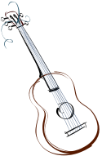
- A variety of styles from rock to classical to alternative are taught.
- Occasionally, electric guitar and electric bass classes are offered if there is enough interest. Please ask the front desk staff for more information.
Performance Level |  |  | ―
Parent Attendance |  |  | Not required
Home Instrument |  |  | Required
Advance to |  |  | Year 1: Year 2  Year 2: Year 3  Year 3: Group or Private lessons
SINGLE PAYMENT*
Registration Fee Concert Fee Tuition per Lesson Annual Tuition Total
Per Year | $65.00 |  | $26.50 |  | $26.50 |  | $1,033.50 |  | $1,125.00
MONTHLY FINANCE PLAN*
Registration Fee First Payment 9 Post-dated payments Total
Per Year |  | $65.00 |  | $190.00 |  | $100.00 |  | $1,155.00
First payment post-dated September 1st and remaining payments post-dated the 1st of each month. The monthly finance option is based on the single payment total plus a finance fee of $3.00 per month.
*Please note: The above fees are based on 39 lessons. Registration and Tuition fees will be pro-rated based on lesson day and start date.

22

